San Jose State University

EE250 (Section 2) Fall 2019 Prof. Kamali

Solution to Problem Set #1

1. Problem 2.34
a) 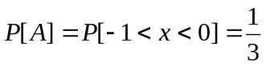
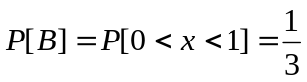
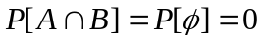

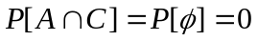

b)
Direct Computation:
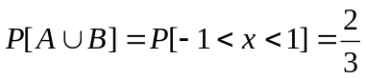
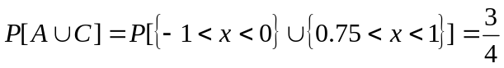

Using axioms and corollaries:
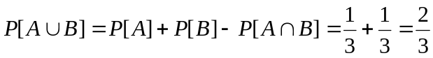
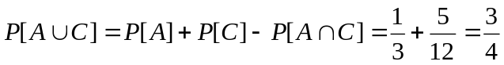

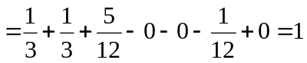

2. Problem 2.81
a)
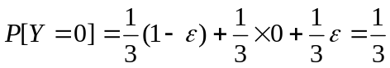

Similarly
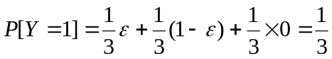
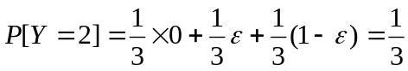

b) Using Bayes’ Rule

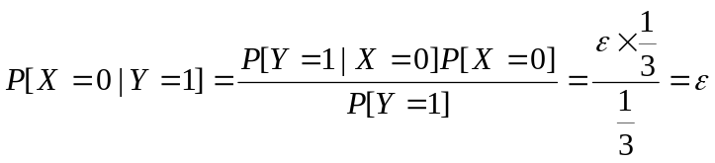
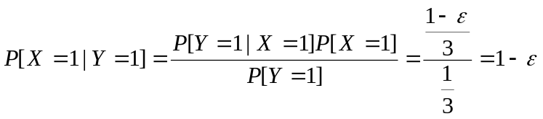
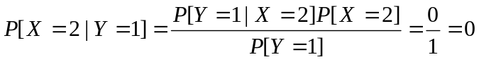

- Problem 2.127
a) 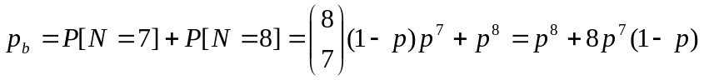

b) 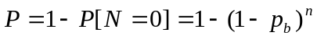
Thus 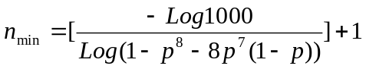 where [x] is the integer part of x.

For instance if 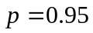, 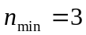.

- [Midterm Problem, Fall 2005] What is the probability that five guests of a twenty floor hotel all stay in different floors (no pair of them are in the same floor) if

- Any guest can stay in any floor?
- Two smokers of the group must stay in four smoking floors and the rest must stay in sixteen non-smoking floors.

Solution:
a) The first guest can be in any floor, the second can stay in 19 out of 20, the third in 18 out of 20, etc.

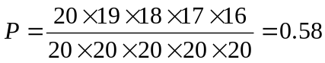

- Two smokers can stay in four smoking floors and three others can stay in the other sixteen floors. So using the result of the previous section.

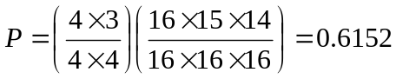

- [Midterm Problem, Spring 2008] Two dices (one black and one white) are rolled simultaneously five times. What is the probability that the number on the black dice be larger than the number on the white dice more than twice?

Solution:
In rolling two dices simultaneously, there are 6x6 = 36 possibilities. In six of these possibilities, the numbers on the dices are the same. In 15 cases, black dice is larger and in the other 15 cases white dice is larger. Rolling the dices five time creates a binomial distribution with 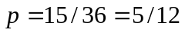 and 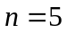.

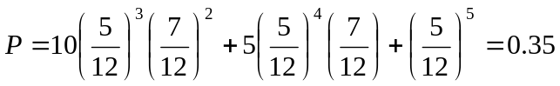

- [Midterm Problem, Fall 2010] Suppose  and are two real numbers picked randomly and independently between 0 and 1. Find 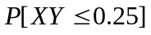.

Solution:
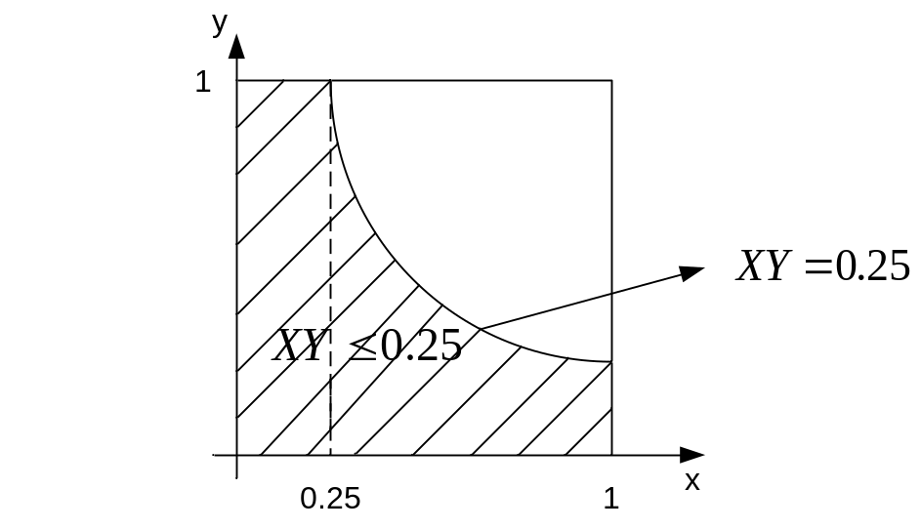

Since both and are uniform random variables, the probability of a region is the ratio of its area to the overall area.

- [Midterm Problem, Spring 2015] A fair coin is tossed ten times.
- What is the probability that all ten tosses produce the same result?
- What is the probability that the results alternate, i.e., Tail is followed by Head and Head is followed by Tail?
- What is the probability that the first five tosses produce identical results?

Solution:

- There are only two ways for ten tosses to produce the same result; all head and all tail. The probability of each of these two outcomes is 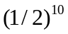and thus the overall probability is 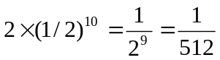.
- There are also two ways for alternative results; THTHTHTHTH and HTHTHTHTHT. The probability of each of these two outcomes is and thus the overall probability is.
- There are two classes of outcomes with identical results in the first five tosses. Those with the head in the first five and those with the tail in the first five. The probability of each of these two classes is 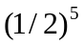and thus the overall probability is 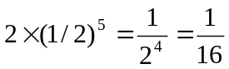.
- [Midterm Problem, Fall 2015] A point M is chosen in random within the unit square (as shown in the following figure).
- What is the probability that M is closer to Y than to X?
- If M is known to be closer to Y than to X, what is the probability that it is closer to Z than to X?
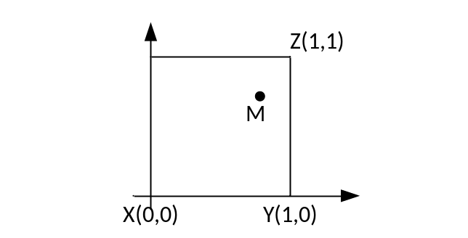

Solution:
Let us denote by A the event that M is closer to Y than to X and denote by B the event that M is closer to Z than to X. The areas associated with these events are shown in the following.

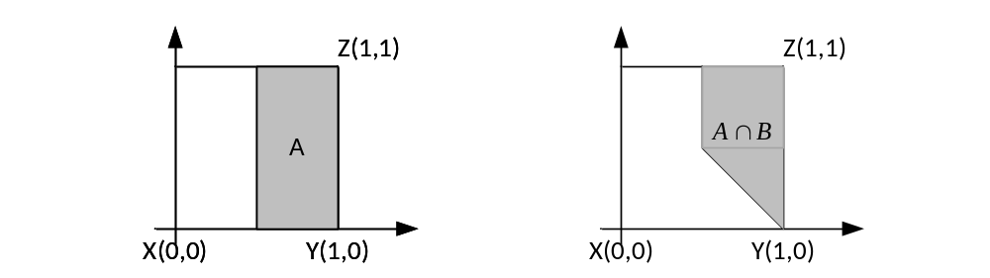

- 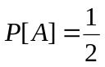
- 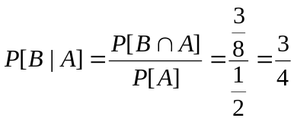

- [Midterm Problem, Fall 2017] In a processing board, there is an important component (A) whose failure is likely going to result in the failure of the board. Specifically, if A fails, board will fail with the probability of 90%. On the other hand, if A is operational, board fails with the probability of only 5%. Assume A fails with probability of 10%.

- Find the probability of the board’s failure.
- What is the probability that an observed board’s failure has been caused by the failure of A?

Solution:

Board’s failure: B
A’s failure: A

Theorem on total probability:

- Bayes’ Rule:
